**UNC Cancer Hospital/Lineberger Comprehensive Cancer Center   
Leukemia Program Clinical Guideline**

**Topic:** Guideline for appropriate patient selection, logistics and supportive care for patients with Acute Myeloid Leukemia receiving venetoclax in combination with a hypomethylating agent (HMA) or low dose cytarabine (LDAC)

**Summary/Recommendations:**

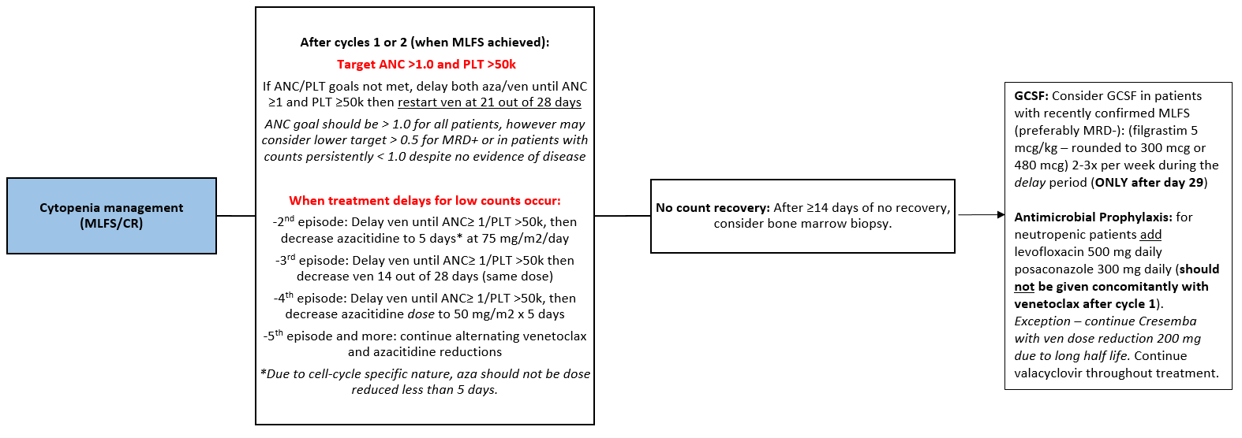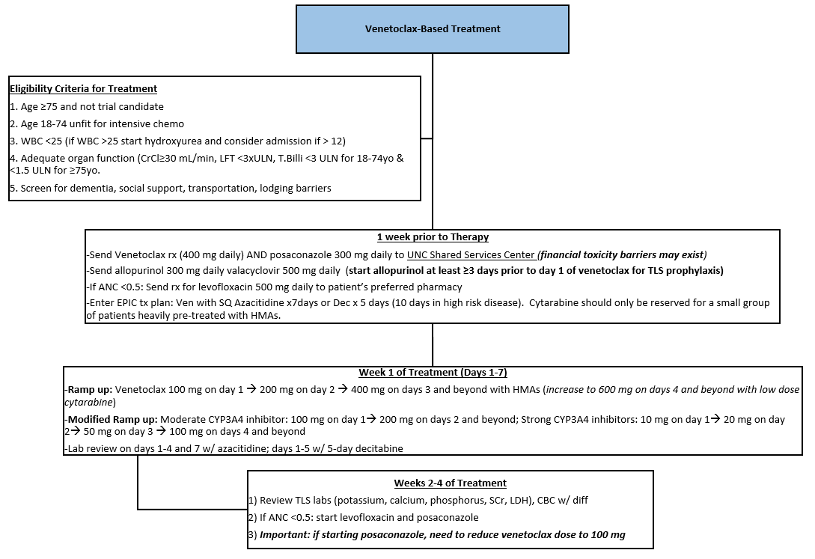

**Background and data summary:**

Venetoclax has been studied in combination with hypomethylating agents (HMA) per Dinardo et al., as well as low-dose cytarabine (LDAC) per Wei et al for upfront treatment in AML in a select patient population, and has shown encouraging response rates. In addition, the recently published VIALE-A trial by Dinardo et. al demonstrated superior complete response and overall survival of azacitidine in combination with venetoclax compared to azacitidine monotherapy for upfront treatment in AML for patients ineligible for intensive induction therapy. In a similar patient group, the VIALE-C trial by Wei et al demonstrated that although overall survival benefit was not seen in the primary analysis, a six-month follow up showed statistically significant overall survival benefit for LDAC plus venetoclax. However, the addition of venetoclax to either HMA or LDAC results in myelosuppression beyond what is expected in monotherapy with either of these backbones. Because of the myelosuppression, the complicated management of AML patients not yet in remission, tumor lysis syndrome mitigation and drug-drug interactions, this regimen should be begun at a leukemia center. Patients who enter remission may receive supportive care at community centers, but patients should still be followed at least monthly by a leukemia specialist.

**Logistics of prescribing venetoclax with combination therapy**

* In general, patients should start their first dose of venetoclax and first dose of HMA or LDAC on the same day (D1) due to synergistic effect of both agents.
* The dose of azacitidine 75 mg/m2 SQ or IV x 7 days (venetoclax 400 mg daily target dose)
  + The treatment plan name is “OP AML AZACITIDINE + VENETOCLAX”
  + This defaults to SQ but the patient if the patient doesn’t tolerate the SQ injections, may switch to IV which will require a new azacitidine order.
  + After cycle one, It is ok to do azacitidine on Days 1-5, 8-9 to give patients the weekend off if they prefer
* The dose of LDAC is 20 mg/m2 SQ x 10 days (venetoclax 600 mg daily target dose)
  + The treatment plan name is “OP AML CYTARABINE + VENETOCLAX”
* Venetoclax + decitabine may be considered as a treatment option if a patient is not eligible for the aforementioned regimens
* Venetoclax monotherapy targets a dose of 800 mg daily, and includes a 4 day ramp-up and 5 days of infusion with fluids
  + The treatment plan name is “OP AML VENETOCLAX”.

*For Inpatients*

* *Venetoclax 100 mg tablets are available for new AML starts only*
* *AML patients who are admitted and are continuing venetoclax should have obtained venetoclax authorization in the outpatient setting and bring medication into the hospital for administration of the patient’s supply*

How to start venetoclax for an AML patient:

1. Send prescription to the UNC Shared Services Pharmacy
   1. Venetoclax comes in 100 mg tablets
      1. The smaller doses are only available as part of the CLL starter pack
      2. It is possible to get 20 mg x 7 days and 50 mg x 7 days wallet packs if needed and as insurance approval allows
   2. The typical dose for AML patients who are NOT on azole antifungals is 400 mg daily when combined with HMA’s, and 600 mg daily when combined with LDAC.
      1. Day’s supply when combined with HMA’s: #120
      2. Day’s supply when combined with LDAC: #180
   3. If you do not want to start this medication immediately upon approval, you may note that in the “notes to pharmacy” text box on the prescription. This will notify our pharmacist at the SSC or elsewhere to not immediately send the medication once the patient is approved. Please communicate this with the pharmacist so they can help prevent errors with the patient starting early.
2. Notify CPP and MAP teammate of a potential new start venetoclax.
   1. If this is a definite new start requiring patient education and coordination, discuss adding this patient to the CPP template.
   2. MAP and CPP will discuss medication access and if patient is agreeable, obtain a signature waiver and income estimates
      1. This signature waiver is needed if the patient’s insurance requires MAP to apply for a grant or manufacturer assistance on behalf of the patient. It is often unknown if this is needed until the patient is no longer in the office. Therefore, we attempt to get this waiver signed by every patient who may require a specialty medication.
   3. You can check the Referral tab in Epic to follow updates on the access of the medication.
3. If you are concerned the patient will incorrectly initiate the medication too early, please let the CPP and MAP know that you want the first fill sent to the Cancer Hospital Infusion Pharmacy (CHIP) and we will arrange that with the pharmacy that is sending it.
   1. This is also important for patients deemed high risk for TLS who we wish to start as an inpatient for monitoring.
   2. Assessment of WBC, LDH, uric acid, and renal function is important to determine safety of initiation in outpatient setting

**Tumor lysis risk assessment and risk mitigation**

Risk of tumor lysis is lower than seen in CLL, but patients with high disease burden (eg. WBC ≥ 40, proliferative and requiring hydroxyurea cytoreduction), patients with renal dysfunction at baseline may be at higher risk among the AML population.

An intra-patient dose-escalation or “ramp-up” has been used to lower the risk of tumor lysis syndrome.

The ramp up for AML patients can be seen in Table 1. The patient should be ramped-up to the target dose before initiating azole prophylaxis. This can be described to the patient and provided in the handout the pharmacist will use to educate the patient

**Table 1. AML venetoclax ramp-up (per package insert)**

|  |  |  |  |
| --- | --- | --- | --- |
|  | **Venetoclax Daily Dose** | | |
| Day 1 | 100 mg | | |
| Day 2 | 200 mg | | |
| Day 3 | 400 mg | | |
| Day 4  and beyond | 400 mg  in combination with  azacitidine or decitabine | 600 mg  in combination with  LDAC | 800 mg when venetoclax used as monotherapy  (Konopleva et al) |

1. A prescription should be sent for allopurinol 300 mg daily to the patient’s local pharmacy or our Central Outpatient Pharmacy.
   1. Ideally a patient should begin this medication at least 48 – 72 hours prior to initiation of venetoclax, but generally is not harmful to go ahead and initiate allopurinol on the day venetoclax prescription is sent so it is not forgotten.

**Infection prophylaxis and Drug-Drug Interactions:**

* Venetoclax is a substrate of CYP3A4 and PGP. To date, there has been limited study of co-administration of venetoclax with moderate or strong inhibitors of these proteins.
* Review the medication list for interactions. The pharmacy team is happy to help. Some common interacting medications include: azole antifungals (discussed below), erythromycin, diltiazem, verapamil, amiodarone, carvedilol, and protease inhibitors.
  + Recommend changing diltiazem, verapamil, and carvedilol if possible in consultation with their PCP or cardiologist
  + Recommend 50% dose reduction of venetoclax with amiodarone
* All AML patients should start valacyclovir 500 mg daily upon diagnosis for prevention of HSV and VZV infections.
* For ANC < 0.5, initiate levofloxacin 500 mg daily.
* For ANC < 0.5, initiate an azole antifungal (prefer posaconazole) **Antifungal medications will be sent for authorization and copay assessment upon treatment initiation. Prophylaxis should start no sooner than Day 8 in patients with an ANC < 0.5, followed by a venetoclax dose reduction (Ref: ASCO/IDSA Guidelines).**
  + Posaconazole and voriconazole are strong CYP3A4 inhibitors, and require a 75% dose reduction of venetoclax. Therefore when the target dose for venetoclax is 400 mg, the appropriate dose while on a strong CYP3A4 inhibitor is 100 mg daily.
    - When patients are on concomitant strong CY3A4 inhibitors and LDAC in which the target dose of venetoclax is 600 mg, venetoclax should be dosed at 100 mg daily due to limitations of tablet sizes
  + Fluconazole (400 mg) and isavuconazole are moderate CYP3A4 inhibitors, and require a 50% dose reduction of venetoclax. Therefore when the target dose for venetoclax is 400 mg, the appropriate dose while on a moderate CYP3A4 inhibitor is 200 mg daily.
    - When patients are on concomitant moderate CY3A4 inhibitors and LDAC in which the target dose of venetoclax is 600 mg, venetoclax should be dosed at 300 mg daily.
  + When these agents are being added on for prophylaxis in this setting, loading is not necessary for posaconazole on the outpatient side; however, patients starting isavuconazole should be LOADED (372 mg every 8 hours x doses then 372 mg daily thereafter)
  + If a patient’s ANC is < 0.5 prior to the ramp-up, the recommendation would be:
    - Allow adequate time for azole wash-out prior to venetoclax initiation (at least 5 days for posaconazole)
    - Complete full ramp-up to target dose of venetoclax
    - On Day 8 of Cycle 1, if patient’s TLS labs stable, dose reduce venetoclax and initiate azole per recommendations below. They should see a provider on this day for evaluation.

Dosing recommendations for initiation and discontinuation of azole antifungals

* If at target dose of venetoclax and wish to START an azole antifungal the following is recommended:
  + Dose reduce venetoclax to 100 mg if starting posaconazole or voriconazole OR dose reduce venetoclax to 200 mg if starting fluconazole 400 mg or isavuconazole
  + Initiate the azole (isavuconazole: LOAD; posaconazole: 300 mg daily)
  + Continue on venetoclax 100 mg or 200 mg
* If at target dose of venetoclax while on an azole antifungal, and wish to STOP the azole, the following is recommended:
  + Discontinue the azole antifungal
  + At 48-72 hours, increase venetoclax to target dose
    - It should be noted that isavuconazole has a very long half-life. Monitor patient closely for toxicity. Patients should be outside risk of TLS

Dosing recommendations for ramp-up while on concomitant azole therapy

* Patients who require active treatment of an azole antifungal will require a unique ramp-up
* Send a prescription for the Venetoclax Starting Pack (used for CLL ramp-ups).
  + The dosing pack will likely be shipped to CHIP. This is a good thing since the patient will require very careful and specific instructions of how to use the pack for their ramp-up.
* Follow the following ramp-up, which is based off the package insert ramp-up on posaconazole with the adjustment of the target dose to 100 mg due to tablet size limitations:
  + Day 1: 10 mg
  + Day 2: 20 mg
  + Day 3: 50 mg
  + Day 4: 70 mg
  + Day 5 and beyond: 100 mg
* A prescription will have to be sent for the 100 mg tablets. Patient has about 3 weeks of therapy within the starting pack as this contains about 21 x 100 mg tablets.

**Management of myelosuppression**

All patients should have a bone marrow biopsy for disease assessment after cycle 1 given that median time to response = 1.0 months. Treatment will be adjusted as follows:

* Persistent leukemia (e.g. > 5% blasts): Continue for at least 1 more cycle. Unlike the use of HMA’s in the treatment of myelodysplasia, the median time to response was 1 cycle. There were outliers (e.g. 5 to 13.3 months) but these are the exceptions. While patients may take several cycles to reach their best response, we would consider a change in regimens if there is no improvement after two cycles.
* The first morphologically leukemia free state (MLFS1, defined as < 5% blasts with 200 cells counted) or CRi with ANC < 1.0 (or 0.5) or platelets < 50: follow recommendations illustrated in Table 3.

**Table 2. Recommended monitoring of blood counts while on venetoclax/azacitidine**

|  |  |
| --- | --- |
| **All patients receive a CBC with differential and CMP per the following recommendations:** | |
| **Cycle 1**  Week 1  Weeks 2 – 4 | Days 1, 2, 3, 4 (ramp-up*) and Day 7  Weekly  *Increase frequency to 2 – 3 times weekly if requiring transfusion support* |
| **Cycle 2 and beyond**  Week 1  Weeks 2 – 4 | Days 1, 4, and 7  Every 2 weeks  *Increase frequency to 2 – 3 times weekly if requiring transfusion support* |
| **\*** Ramp-up monitoring also includes TLS labs and IV fluids | |

**Suggested follow-up:**

* **Utilize smart phrase ‘amlvenetoclaxscheduling’ to help schedule labs, infusion, and provider appointments.**
* Labs: see Table 2 for recommended monitoring. Lab appointments will be needed for each day labs are required. Labs should exist within the treatment plan.
* Cycle 1 Day 1: Patients should see at minimum the CPP in clinic. A provider visit (MD/APP) is optional depending on if the patient had been seen within 1 week by a provider.
* Patient should follow-up with the CPP on D8 of C1, and have a provider visit (MD/APP) during week 2 in conjunction with labs.
  + Consider Nurse Navigator call on C1D10 for compliance if necessary.
* Patient should follow up with CPP once between D15 in conjunction with labs.
* An APP visit should be scheduled mid cycle ~D15-22
* A bone marrow biopsy should be scheduled between day 24-28 with labs during Cycle 1 and a provider appointment should follow this during week 4/5 with labs to follow-up results of procedure. This will inform how to proceed with Cycle 2.
* Cycle 2 and beyond:
  + Every 1-2 week provider appointments should continue until the patient achieves a CR or until a patient achieves a dosing regimen where they are no longer have prolonged neutropenia requiring chemotherapy dose adjustments.
  + Once CR is achieved and lab monitoring is stable, a provider visit every 2-4 weeks is warranted.
  + The CPP can be involved as needed for help with medication dosing adjustments, drug interactions, and initiation of supportive care.

**Table 3. Recommendations for cytopenia management in a patient with confirmed MLFS or CR*^**

|  |  |  |
| --- | --- | --- |
|  | **Recommendation** | **Other Considerations** |
| 1st occurrence (consider this dose reduction in all patients following MLFS/CR, particularly if MRD-) | Hold both venetoclax and azacitidine until recovery to ANC ≥ 1.0 (or > 0.5 if MRD+) or platelets ≥ 50, restart venetoclax full dose for 21 out of 28 days, continue azacitidine at full dose 75 mg/m2 x 7 days | If cytopenias are unimproved despite holding therapy > 14 days after D28, consider bone marrow biopsy to assess for progressing disease  If recent BMbx reveals MLFS (and ideally MRD negativity) consider GCSF at 5 mcg/kg about 3 times weekly or daily until ANC recovered.  In setting of achieved CR, avoid azole prophylaxis concomitantly with venetoclax (venetoclax will therefore be dosed at 400 mg daily after C1); can consider azole ppx during time off venetoclax in between cycles if ANC < 0.5 |
| 2nd occurrence | Hold both venetoclax and azacitidine until recovery to ANC ≥ 1.0 (or > 0.5 if MRD+) or platelets ≥ 50, then restart venetoclax full dose for 21 out of 28 days, and dose reduce azacitidine 75 mg/m2 x 5 days duration |
| 3rd occurrence | Hold both venetoclax and azacitidine until recovery to ANC ≥ 1.0 (or > 0.5 if MRD+) or platelets ≥ 50, then restart venetoclax full dose for 14 out of 28 days, and azacitidine 75 mg/m2 x 5 days duration |
| 4th occurrence | Hold both venetoclax and azacitidine until recovery to ANC ≥ 1.0 (or > 0.5 if MRD+) or platelets ≥ 50, then restart venetoclax half dose for 14 out of 28 days, and dose reduce azacitidine 50 mg/m2 x 5 days duration |

**References:**

1. Dinardo CD, Pratz KW, Letai A, et al. Safety and preliminary efficacy of venetoclax with decitabine or azacitidine in elderly patients with previously untreated acute myeloid leukaemia: a non-randomised, open-label, phase 1b study. Lancet Oncol. 2018;19(2):216-228
2. Wei AH, Strickland SA, Hou JZ, et al. Venetoclax Combined With Low-Dose Cytarabine for Previously Untreated Patients With Acute Myeloid Leukemia: Results From a Phase Ib/II Study. J Clin Oncol. 2019;37(15):1277-1284.
3. Venclexta (venetoclax) [prescribing information]. North Chicago, IL: AbbVie Inc; July 2019.
4. Konopleva M, Pollyea DA, Potluri J, et al. Efficacy and Biological Correlates of Response in a Phase II Study of Venetoclax Monotherapy in Patients with Acute Myelogenous Leukemia. Cancer Discov. 2016;6(10):1106-